Comparation with cloud instance and local Virtual Machine.



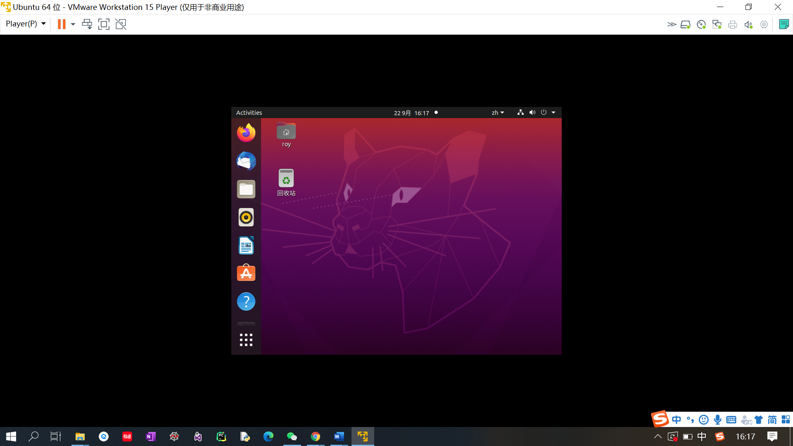

1. The mouse is quite interesting in cloud machine. In fact, there are two mice in the screen, which is quite annoyed for the users. However, in local virtual machine, there is only one mouse in the screen, which is more comfortable.

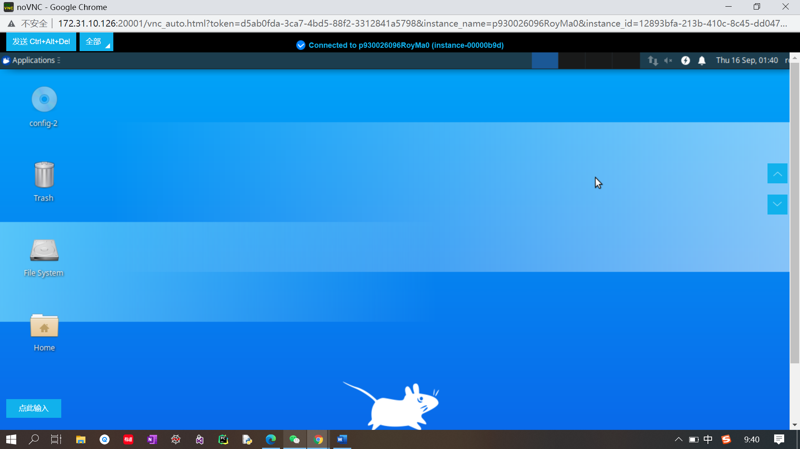



1. The reaction speed is quite different as well. For cloud machine, the reaction is quite slow, and usually crushed suddenly. Sometimes, you have to wait a long time for respond for a click. For virtual local machine, the respond speed is quite fast and smooth. It is similar to that of the current computer and provide a better user experience.

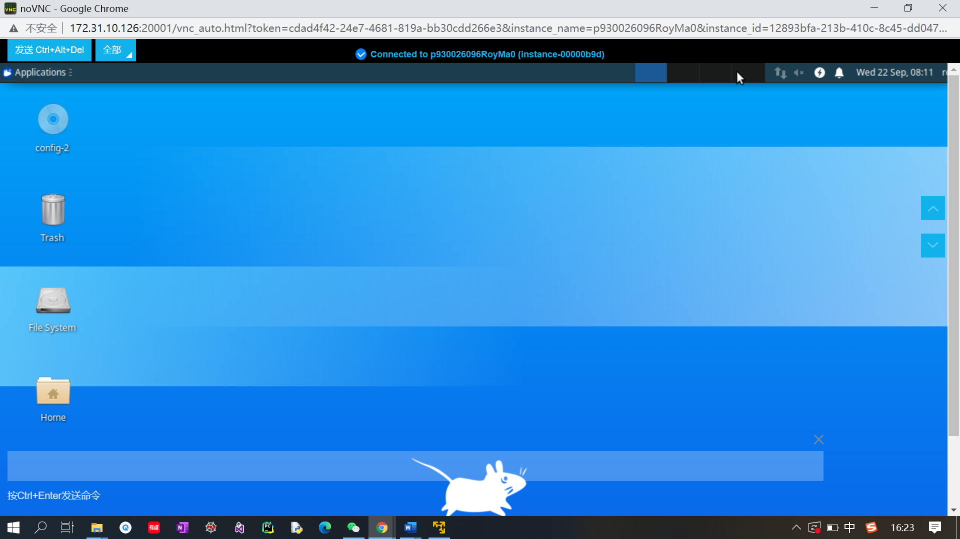

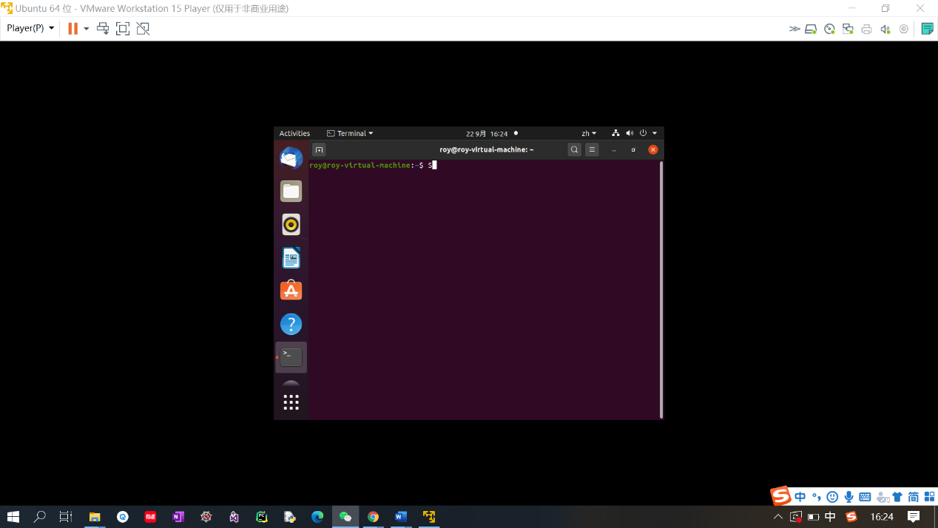

1. The command enter place is quite different. For cloud machine, there is only one window at the bottom of the user interface. For local virtual machine, you can turn on the terminal, and enter command line there.



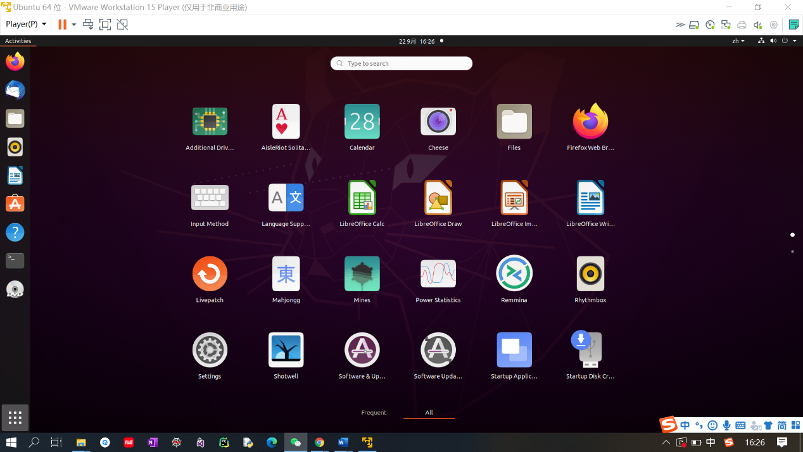

1. The user interface is quite different as well. For a cloud instance, the user interface is quite similar to that of older version window’s operating systems. However, in local virtual machine, the occasion transmission is quite smooth and similar to that of Apple operating systems.





1. Normally, the local virtual machine has a large space for different applications and can set all the setting similar to a functionally comprehensive computer. But for the cloud instance, it usually only install the basic application or the application you frequently use, since it will cost more if you need more cloud space.